JScript over Dynamic Language Runtime (Internal Trial)

March 2nd, 2007
© Microsoft Corporation, 2007. All rights reserved.
Contents
1.0 Introduction
2.0 Software Requirements
3.0 Installation
4.0 Using JScript
5.0 What is working?
6.0 What is not there
7.0 Known Issues
8.0 Useful Links
[Top]

1.0 Introduction

Dynamic languages like JScript are becoming increasingly popular with both developers and non-developers. For enabling dynamic languages to take advantage of Microsoft's technologies like Common Language Runtime (CLR), a new framework is being built. This new framework called Dynamic Language Runtime (DLR) will run over CLR and Telesto (slim CLR) to allow dynamic language developers access to great CLR features like reflection, runtime code generation, cross-language interaction, superb GC, etc.
We are now ready to present the first Internal Trial of JScript on top of DLR.
[Top]

2.0 Software Requirements
JScript has following prerequisites –
- Windows XP Service Pack2 or Windows Vista
- Microsoft .NET Framework 2.0 or Telesto
- Dynamic Language Runtime

Note: Dynamic Language Runtime will be provided along with the JScript release.
[Top]

3.0 Installation
The JScript distribution does not require any installation. Please add the path of JScript distribution to the system path.
[Top]

4.0 Using JScript
JScript can be run by invoking jsx.exe from the command prompt. There are two ways to use ‘jsx.exe’ –
- Invoking with file name as parameter – If ‘jsx.exe’ is invoked with JScript file information, it will run the JScript code of the file.
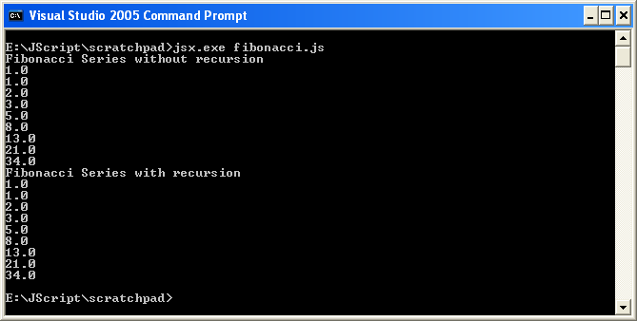

- Interactive console – When ‘jsx.exe’ is invoked without any parameter a command prompt is return where user can run JScript code.
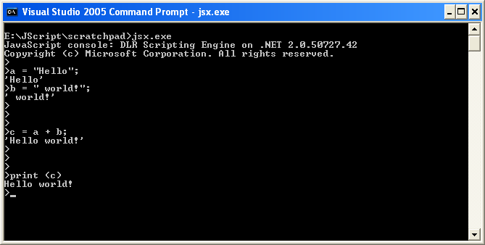

Another way of using JScript is through Nessie which is a lightweight programming editor and interactive development tool. Please refer to Nessie’s documentation for more details.
[Top]

5.0 What is working
This JScript implementation and Dynamic Language Runtime are work in progress. At present not all JScript features/construct work. Please refer to section 6.0 for list of features which are not yet implemented. For the working features some corner cases might still not work.
[Top]

6.0 What is not there
The following JScript features are coming in later releases –
- Support for RegExp literals, Object literals and Array literals
- Support for labels, break and continue
- Support for with and in
- Support for var declaration handling (attributes)
- Regular Expression only works on .NET platform. Support on Telesto will come in future releases.
- Ability to program against IE DOM (Not planned for MIX 07)
- Support for ECMA Script 4 (Not planned for MIX 07)
Apart from these following features will be coming in later releases –
- Ability to call into .NET classes
- Ability to import modules from other DLR languages
[Top]

7.0 Known Issues

[Top]

8.0 Useful Links
More information is available at homepage for JScript implementation over Dynamic Language Runtime is http://devtools/jscript/managed.

Some working JScript samples are available at http://devtools/jscript/managed/Shared%20Documents/Samples.

[Top]

